**Report z cvičenia č. 7**

**Rastislav Kupčík, Pavol Trník**

**Zadanie:**

* Generovať 4 TCP toky (každý 50 kbps) + jeden UDP tok (50 kbps)
* 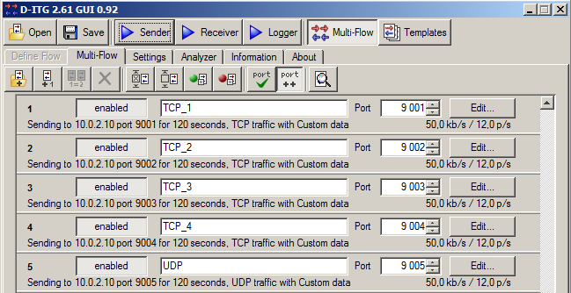Otestovať rôzne scenáre pre FIFO, CBWFQ, WRED a WRED + ECN

V prvom kroku bolo potrebné nastaviť značkovanie paketov. Pre TCP toky boli použité značky AF11, AF12, AF31, AF33, a pre jediný UDP tok značka AF21.

access-list 101 permit tcp any host 10.0.2.10 eq 9001

access-list 101 permit ip any any dscp af11

access-list 102 permit tcp any host 10.0.2.10 eq 9002

access-list 102 permit ip any any dscp af12

access-list 103 permit tcp any host 10.0.2.10 eq 9003

access-list 103 permit ip any any dscp af31

access-list 104 permit tcp any host 10.0.2.10 eq 9004

access-list 104 permit ip any any dscp af33

access-list 105 permit udp any host 10.0.2.10 eq 9005

access-list 105 permit ip any any dscp af21

class-map match-all TCP_1

match access-group 101

class-map match-all TCP_2

match access-group 102

class-map match-all TCP_3

match access-group 103

class-map match-all TCP_4

match access-group 104

class-map match-all UDP

match access-group 105

Následne bolo potrebné aplikovať politiku „znackovanie“ na rozhranie FastEthernet 0/0 na smerovači R1.

policy-map znackovanie

class TCP_1

set dscp af11

class TCP_2

set dscp af12

class TCP_3

set dscp af31

class TCP_4

set dscp af33

class UDP

set dscp af21

**Scenár č.1: FIFO**

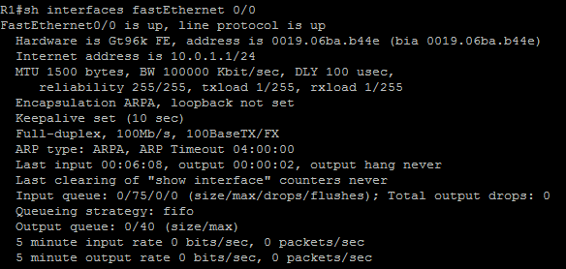

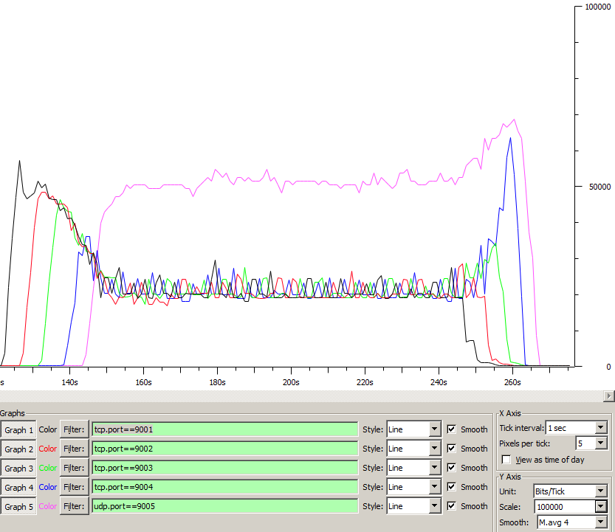

_________________________________________________

**************** TOTAL RESULTS ******************

__________________________________________________________

Number of flows = 5

Total time = 145.863000 s

Total packets = 4222

Minimum delay = 189.077000 s

Maximum delay = 204.352000 s

Average delay = 195.376917 s

Average jitter = 0.227388 s

Delay standard deviation = 3.497361 s

Bytes received = 2048062

Average bitrate = 112.327979 Kbit/s

Average packet rate = 28.944969 pkt/s

Packets dropped = 0 (0.00 %)

Average loss-burst size = 0 pkt

Error lines = 0

* Vidíme, že UDP prevádzka si uchmatla najviac BW linky
* Straty boli v tomto prípade 0%

**Scenár č.2: CBWFQ**

* Vytvorili sme si novú policy-map s názvom CBWFQ
* Každej triede sme vyhradili minimálnu šírku pásma 25%
* AF31 a AF33 patrili do triedy class-default
* Konfigurácia:

policy-map CBWFQ

class TCP_1

bandwidth percent 25

class TCP_2

bandwidth percent 25

class UDP

bandwidth percent 25

class class-default

fair-queue

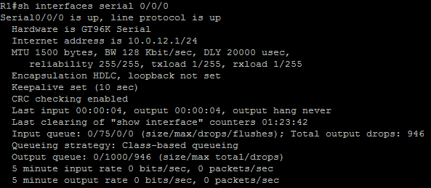

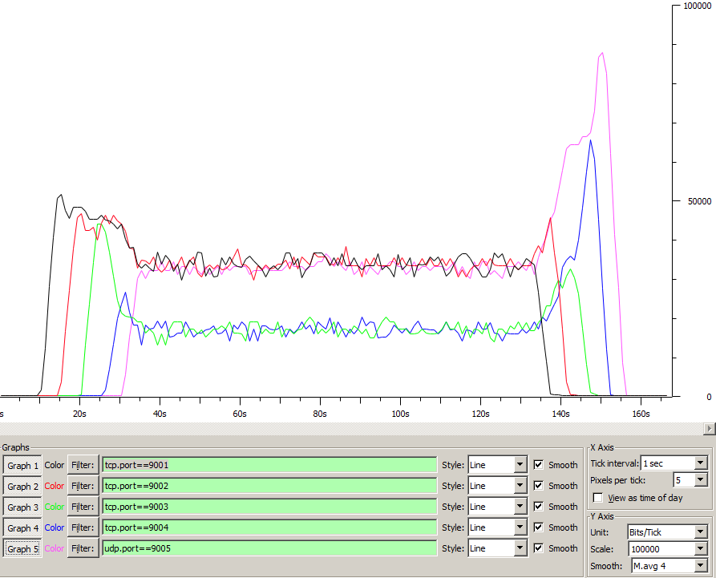

_____________________________________________________

**************** TOTAL RESULTS ******************

__________________________________________________________

Number of flows = 5

Total time = 146.018000 s

Total packets = 4280

Minimum delay = 191.378000 s

Maximum delay = 205.485000 s

Average delay = 198.022146 s

Average jitter = 0.141719 s

Delay standard deviation = 3.591572 s

Bytes received = 2071352

Average bitrate = 113.484748 Kbit/s

Average packet rate = 29.311455 pkt/s

Packets dropped = 384 (8.23 %)

Average loss-burst size = 1.386282 pkt

Error lines = 0

**Scenár č.3: WRED**

* Pre triedu class-default bolo potrebné spustiť mechanizmus WRED

policy-map CBWFQ

class TCP_1

bandwidth percent 25

class TCP_2

bandwidth percent 25

class UDP

bandwidth percent 25

class class-default

fair-queue

random-detect

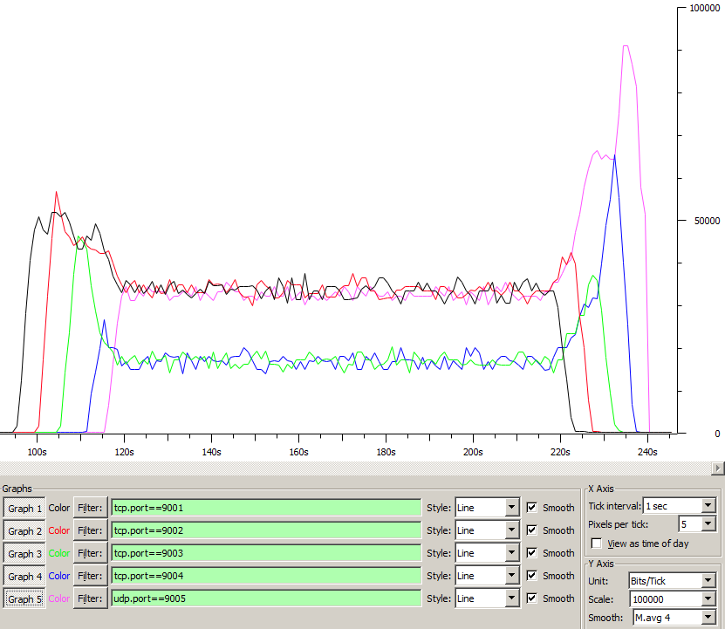

__________________________________________________________

**************** TOTAL RESULTS ******************

__________________________________________________________

Number of flows = 5

Total time = 146.013000 s

Total packets = 4270

Minimum delay = -21.964000 s

Maximum delay = -5.499000 s

Average delay = -10.242776 s

Average jitter = 0.130276 s

Delay standard deviation = 3.285243 s

Bytes received = 2066506

Average bitrate = 113.223124 Kbit/s

Average packet rate = 29.243971 pkt/s

Packets dropped = 387 (8.31 %)

Average loss-burst size = 1.316327 pkt

Error lines = 0

----------------------------------------------------------

**Scenár č.4: WRED + ECN**

* V policy-map CBWFQ bolo nutné doplniť do triedy class-default k WRED ešte aj ECN

policy-map CBWFQ

class TCP_1

bandwidth percent 25

class TCP_2

bandwidth percent 25

class UDP

bandwidth percent 25

class class-default

fair-queue

random-detect

random-detect ecn

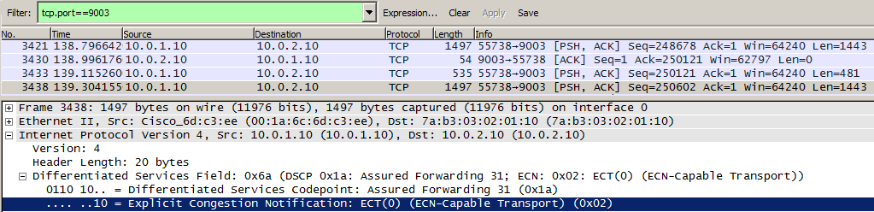

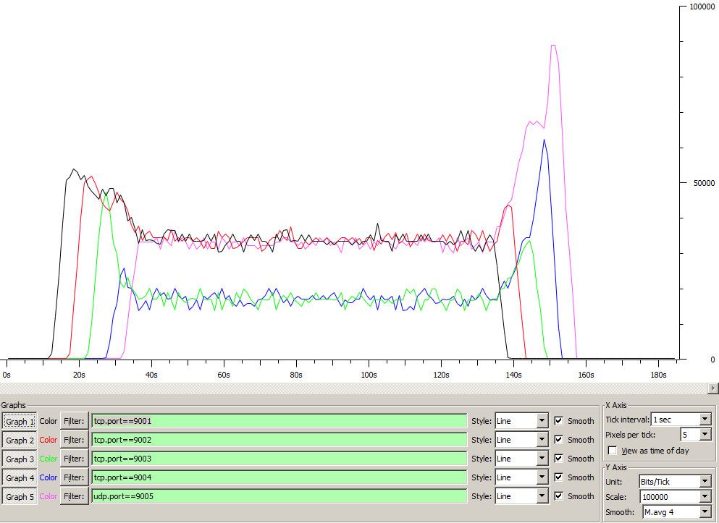

__________________________________________________________

**************** TOTAL RESULTS ******************

__________________________________________________________

Number of flows = 5

Total time = 140.362000 s

Total packets = 4237

Minimum delay = 245.245000 s

Maximum delay = 257.956000 s

Average delay = 250.680774 s

Average jitter = 0.132135 s

Delay standard deviation = 3.297630 s

Bytes received = 2050657

Average bitrate = 116.878186 Kbit/s

Average packet rate = 30.186233 pkt/s

Packets dropped = 385 (8.33 %)

Average loss-burst size = 1.341463 pkt

Error lines = 0

----------------------------------------------------------